Using lidar to track Lake Michigan bluff retreat and inform local communities

Reading

By Carolina Michel1, Chelsea Scott2, Sally Stevens3, Kate Flick4, and Luke Zoet3

1Undergraduate Education, Michigan State University, East Lansing, MI

2School of Earth and Space Exploration, Arizona State University, Tempe, AZ

3University of Wisconsin-Madison, Department of Geoscience, Madison, WI

4 Department of Earth Science, College of the Menominee Nation, Keshena, WI

## Part 1: Background information

### Coastal Erosion in the Great Lakes Region- Why do we care?

Shorelines along the Great Lakes are susceptible to erosion from fluctuations in water levels. When lake levels are high, waves erode the base of bluffs and can trigger bluff instability. Homes, private property, and infrastructure built along coastal bluffs are most vulnerable to slope failure, storm damage, and loss of beaches. Sea walls and rock jetties can temporarily minimize local effects of erosion, but in the long-term, these protection measures disrupt natural sediment supply and worsen erosion downshore. Warming temperatures and loss of winter ice cover due to climate change can lead to increased rates of erosion, in response to greater fluctuations in water levels and more intense storms. **Quantifying how coastlines change over time is critical to evaluate bluff hazards and to better plan development and resource management.** In this lab, we will investigate how bluffs at Port Washington along Lake Michigan have changed through lidar (remote sensing data) and lake-level records. You will interpret these results as if advising a homeowner about the risks of coastal erosion.

**DID YOU KNOW? Bluff Erosion Builds Beaches!**

Eroding bluffs aren’t just a hazard—they’re beach builders! Sediment from bluffs drops to the base, gets sorted by waves and wind, and helps form and maintain beaches and dunes. These systems, in turn, protect the shoreline from further erosion.

### How can we measure change?

#### Lidar

*Lidar* is an acronym for light detection and ranging. Lidar technology is used to create three dimensional representations of the natural and built environment at a resolution of approximately one meter. Along the Lake Michigan coastline, lidar will measure the height of the ground surface, trees, roads, and buildings. Lidar can sometimes measure elevations in shallow water, typically up to a few tens of meters depth. *Bathymetry* is the term used to describe topography underwater, for example, under a lake, river, or ocean. Along with structure-from-motion data collected with a drone, lidar data can be used to calculate topographic slope, an important metric for assessing bluff stability.

Lidar topography can be collected via a lidar instrument on the ground (terrestrial lidar), on an airplane (airborne lidar) or from a satellite (space-borne lidar). The most frequently used lidar is airborne lidar (shown in **Figure 1**), and this assignment focuses on airborne lidar data. To measure the elevation, an aircraft emits a laser pulse (shown in red below), and a portion of that pulse bounces off the ground and back to the aircraft. The travel time of the pulse from the aircraft, to the ground, and back to the aircraft indicates the elevation of ground surface.

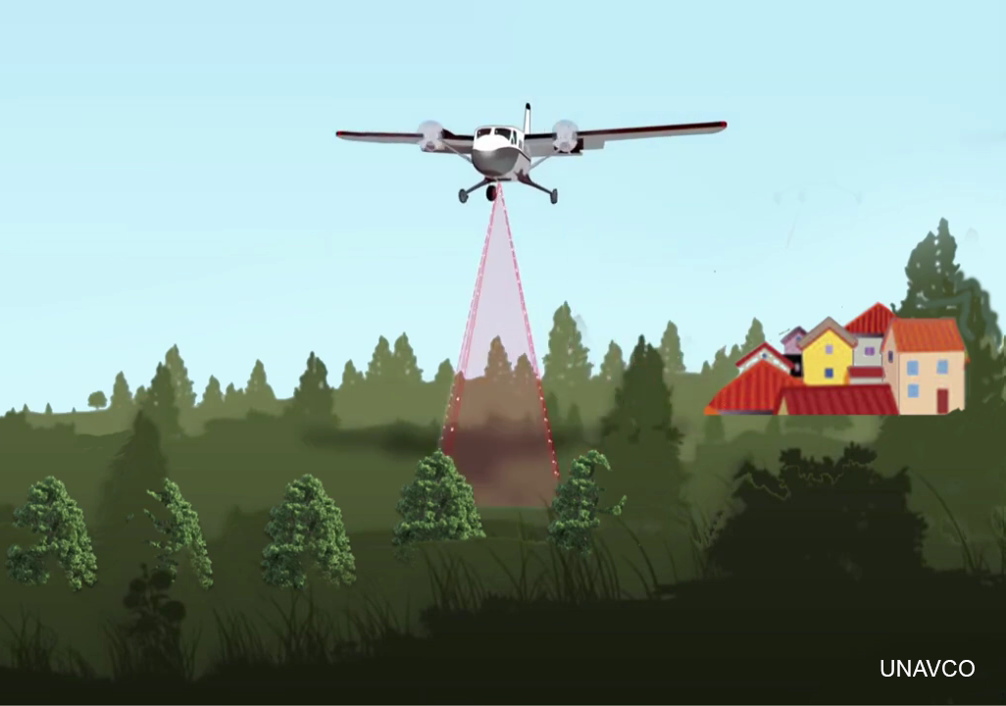

**Figure 1.** Airborne lidar: The aircraft is part of an airborne lidar system that measures the elevation of the ground surface, the trees, and the houses. Image credit: EarthScope

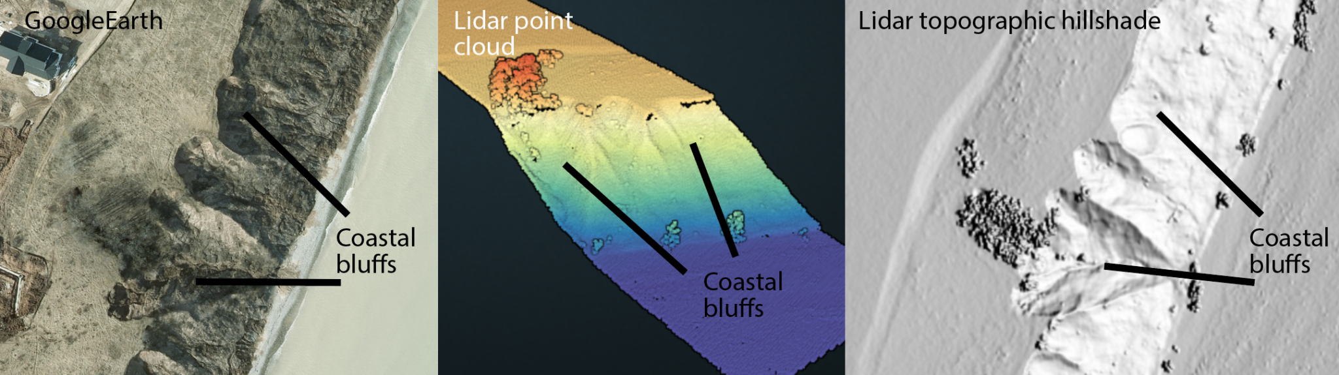

**Figure 2.** Coastal bluffs along the Lake Michigan shoreline as seen with different types of remote sensing data. Left: Satellite imagery from GoogleEarth. The black lines show the eroded faces of the bluffs. Middle: Lidar point cloud topography colored by elevation, showing the bluff shape. Right: Lidar topographic hillshade where the steep cliff faces are shown as a light color and the flatter beach, water, and upslope area are in grey.

We have created a video on how to use Google Earth and hillshades from lidar to observe the change in coastal bluffs in Port Washington. You can access the **Lake Michigan Bluff Retreat Seen with Lidar** video at: <https://youtu.be/7TnTuN8opE4?si=ZxszIg5tIDRhHW6f>. Watching video 1 will help you resolve the lab.

**DID YOU KNOW? Lidar is Revolutionizing Coastal Erosion Monitoring**Along the Great Lakes and ocean coasts, lidar is used to track bluff retreat, dune migration, and beach loss with incredible precision—often integrated with drone imagery and GPS surveys.

#### Topographic differencing

*Topographic differencing* is a technique used to estimate the vertical change in the elevation of the Earth’s surface over time as measured by multiple acquisitions of lidar topography data. This is an important method for measuring how the landscape has changed over the past one to two decades and for understanding and anticipating a range of geologic hazards.

The topographic differencing workflow is shown in **Figure 3**. The differencing begins with two point cloud datasets, each representing the 3D structure of the landscape. Each point in a point cloud has 3D location information (x, y, and z) of the ground surface. In **Figure 3**, a lidar topographic point cloud dataset was acquired both before and after a geologic event of interest. The before/ earlier point cloud is colored blue and the after/ later point cloud is colored pink. These datasets are each gridded to two dimensional grids (called rasters) where each grid element represents the elevation of the ground surface at that location, as shown in the blue to yellow-colored grids. The gridded datasets are then *differenced*, producing the red, white and blue plot shown on the right in **Figure 3**. The values in the gridded plot indicate change over time. Negative values shown in red indicate the ground surface has moved down, for example from erosion or landslides. White means that the ground surface has not changed or has changed very little. Positive values shown in blue mean that the ground surface has moved up, for example from sediment deposition. The differencing shows all of the changes at the Earth’s surface between the lidar acquisitions, for example due to natural processes like erosion, anthropogenic activities like mining, and seasonal changes to vegetation like the growth and loss of leaves on trees.

Topographic differencing measures changes to the Earth’s surface between lidar acquisitions. In many non-coastal areas, publicly-available lidar is collected at most every decade. Along many US coastlines, for example along Lake Michigan, data is collected more often and sometimes even annually. These data are important for many reasons, including for monitoring coastal erosion, assessing storm impact, mapping flood risk, and planning for navigation and infrastructure. Many of these datasets are collected by the National Oceanic and Atmospheric Administration, a US federal agency.

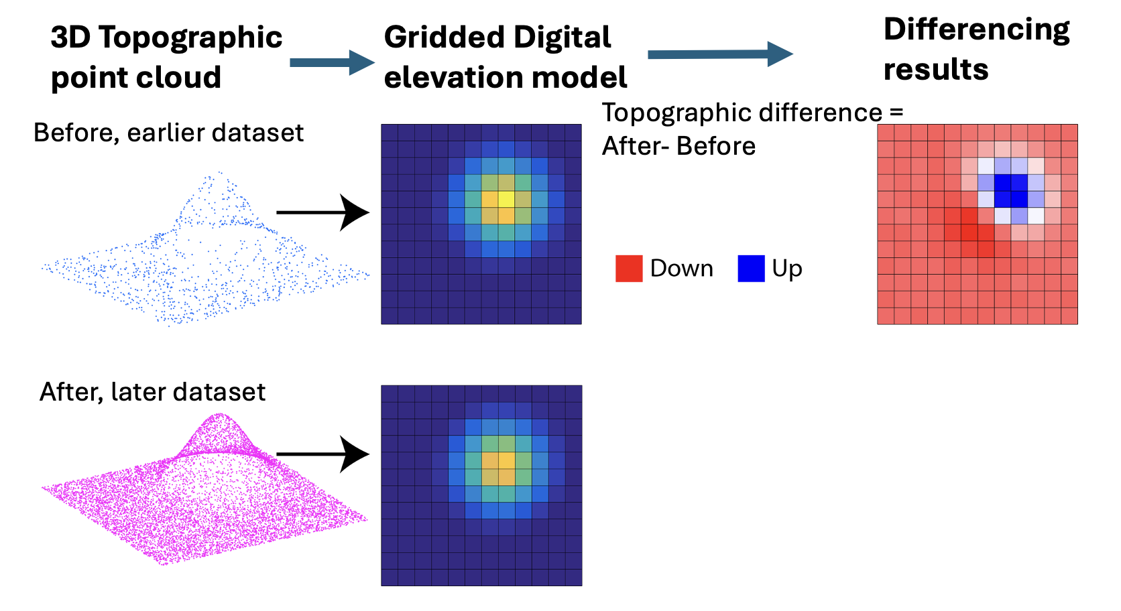

**Figure 3.** Lidar topographic differencing reveals topographic change from ageologic event. The before/ earlier 3D topographic point cloud (blue) and the after/ later point cloud (pink) are gridded to have an identical resolution and grid bounds. The gridded datasets are differenced, producing the red and blue plot shown to the right. Red means that the ground surface has moved down, for example from erosion. White means that the ground surface has not changed or has changed very little. Blue means that the ground surface has moved up, for example from sediment deposition.

You can generate the topographic differencing and visualize it using free platforms, such as Open Topography and QGIS. To learn more, watch video 2, Lake Michigan Shoreline Differencing on OpenTopography ([https://youtu.be/qsX6385uAiQ?si=G0TyBk9IKHeyOE9V)](https://youtu.be/qsX6385uAiQ?si=G0TyBk9IKHeyOE9V)

#### Field sketching

Sketching a field site from photographs or in-person is a critical part of the scientific process in geology and is a skill that is important in the workforce. Geologists create field sketches to record observations and connect landscapes to geologic processes. In addition,sketchingprovides time to slow down and think about the geology in a way that is different from simply taking a photograph.

Field sketches document observations. Geologists spend years learning the art and science of making these sketches.Geologists do not aim to create beautiful art when sketching, so do not worry if you do not know how to paint or draw. Today is a great time to practice how to do field sketches. The purpose of field sketching is to help you notice geological features and inferred processes that created the landscape.

Helpful steps in field sketching:

(1) Decide the area that you want to sketch. (How large is the area that you want to cover?)

(2) Draw three to four features in the landscape. (What are the dominant features in this area?)

(3) Draw the vegetation, if present.

(4) Add in other geologic features or parts of the landscape that have not already been drawn

(5) Annotate features. (Add labels, add compass directions, etc.)

(6) Add a scale that has a fairly consistent size so the reader understands the sense of scale for the other features in the sketch. (Examples include drawing a person, house, vehicle, road, or rock hammer)

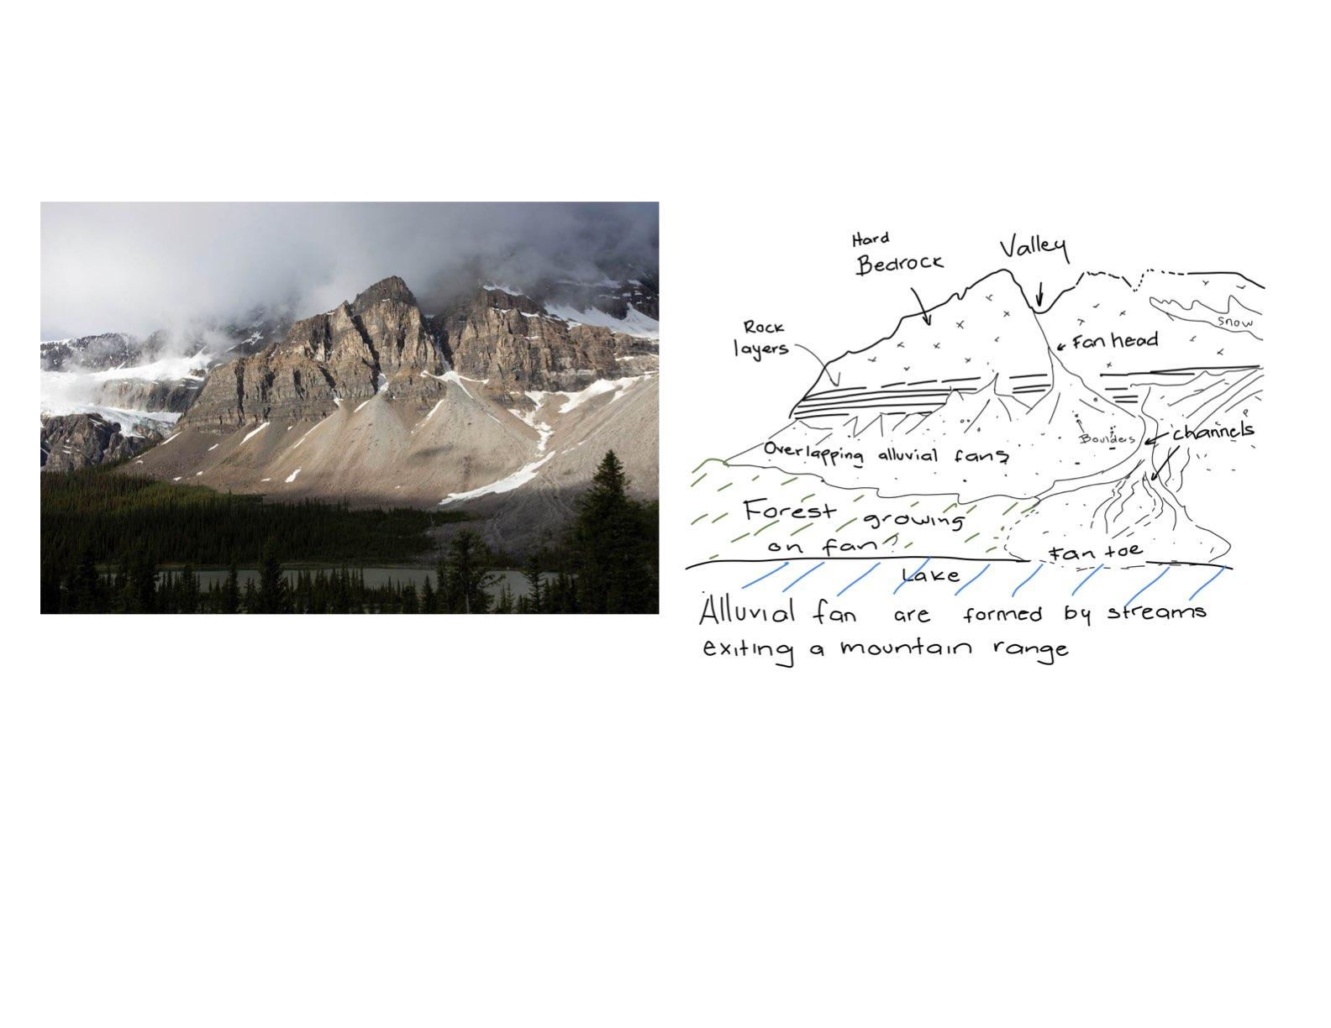

**Figure 4**. Example of a geologic sketch (right) from a photograph of Banff National Park, Canada. Note the labels for key features (bedrock, fans, lake) and annotations. The trees and forests provide an idea for the scale. You will be asked to create a sketch from an image during the lab. Photo on the left shown for reference, courtesy of Marli Miller (geologypics.com)

In this lab, you’ll get hands-on experience with the same tools geoscientists use to study changing coastlines. By working with lidar data and practicing field sketching, you’ll see how bluffs along Lake Michigan have shifted over time and what that means for people living nearby. Think of this as a chance to step into the role of a geoscientist: you’ll measure, observe, and then explain your results as if you were advising a homeowner about coastal erosion risks. The skills you practice here—analyzing data, making careful observations, and connecting them to real-world challenges—are the foundation of how geologists turn science into solutions.

**RESOURCES AND FURTHER READING**

Internet Geography. (n.d.). Field sketches in Geography. <https://www.internetgeography.net/field-sketches-in-geography/>

Koran, M. (2021, October 30). *‘The water always wins’: Calls to protect shorelines as volatile Lake Michigan inflicts heavy toll*. Wisconsin Watch.<https://wisconsinwatch.org/2021/10/calls-to-protect-shorelines-as-volatile-lake-michigan-inflicts-heavy-toll/>

Koran, M. (2021, November 4). *As Lake Michigan shoreline vanishes, Wisconsinites try to fight waves with walls*. Wisconsin Watch. [https://wisconsinwatch.org/2021/11/as-lake-michigan-shoreline-vanishes-wisconsinites-fight-waves-with-walls/](https://wisconsinwatch.org/2021/11/as-lake-michigan-shoreline-vanishes-wisconsinites-fight-waves-with-walls/?utm_source=chatgpt.com)

Koran, M. (2022, August 13). *15 years later, Wisconsin university’s massive Lake Michigan seawall frustrates downstream neighbors*. Wisconsin Watch.<https://wisconsinwatch.org/2022/08/15-years-later-wisconsin-universitys-massive-lake-michigan-seawall-frustrates-downstream-neighbors/>

National Oceanic and Atmospheric Administration. (n.d.). *Office for Coastal Management*. U.S. Department of Commerce. https://coast.noaa.gov

National Oceanic and Atmospheric Administration. (2010). 2020 USACE NCMP Topobathy Lidar: Lake Michigan (IL, IN, MI, WI). Distributed by OpenTopography. <https://portal.opentopography.org/noaaDataset?noaaID=5042>, last accessed 2025-01-01.

National Oceanic and Atmospheric Administration. (2012). [2012 USACE NCMP Topobathy Lidar: Lake Michigan (IL,IN,MI,WI)](https://portal.opentopography.org/noaaDataset?noaaID=10170&minX=-87.89536030284634&minY=43.34650504076134&maxX=-87.83356850352115&maxY=43.385473130721124). Distributed by OpenTopography. <https://portal.opentopography.org/noaaDataset?noaaID=10170>, last accessed 2025-01-01.

National Oceanic and Atmospheric Administration. (2020). FEMA Lidar: Ozaukee County (WI). Distributed by OpenTopography. <https://portal.opentopography.org/noaaDataset?noaaID=9232>, last accessed 2025-01-01.

The Associated Press. (2020, January 4). *Erosion claims home along Lake Michigan bluff; lake levels remain near record highs*. MPR News. [https://www.mprnews.org/story/2020/01/04/erosion-claims-home-along-lake-michigan-bluff](https://www.mprnews.org/story/2020/01/04/erosion-claims-home-along-lake-michigan-bluff?utm_source=chatgpt.com)

University of Wisconsin Sea Grant Institute. (n.d.). *Coastal processes and erosion*. Board of Regents of the University of Wisconsin System. <https://www.seagrant.wisc.edu>

U.S. Geological Survey. (n.d.). *USGS coastal change hazards*. U.S. Department of the Interior. <https://www.usgs.gov/coastal-change-hazards>

Wisconsin Coastal Management Program. (n.d.). *Wisconsin coastal management program*. Wisconsin Department of Administration. <https://coastal.wisconsin.gov>

Wisconsin Department of Natural Resources. (n.d.). *Coastal management and shoreland zoning*. State of Wisconsin. https://dnr.wisconsin.gov

Wisconsin Geological and Natural History Survey. (n.d.). *Geologic hazards and coastal processes*. University of Wisconsin–Madison Division of Extension. <https://wgnhs.wisc.edu>

WXYZ-Detroit. (2023, March 23). *Experts warn erosion along Great Lakes to worsen amid ice decline, climate change*. WXYZ.<https://www.wxyz.com/news/experts-warn-erosion-along-great-lakes-to-worsen-amid-ice-decline-climate-change>

Zoet, L., Rawling, J., Roland, C., Krueger, R., Volpano, C. A., & Theuerkauf, E. (2021). An Overview of Coastal Bluff Stability Along the Great Lakes. In *Geological Society of America Abstracts* (Vol. 53, p. 361505). <https://gsa.confex.com/gsa/2021NC/webprogram/Paper361505.html>