OpenTopography

Using lidar to track Lake Michigan bluff retreat and inform local communities

Laboratory Exercise
By Carolina Michel¹, Chelsea Scott², Sally Stevens³, Kate Flick⁴, and Luke Zoet³.
Acknowledgements: Reviewed/Edited by Beth Pratt-Sitaula

¹Undergraduate Education, Michigan State University, East Lansing, MI
²School of Earth and Space Exploration, Arizona State University, Tempe, AZ
³University of Wisconsin-Madison, Department of Geoscience, Madison, WI
⁴ Department of Earth Science, College of the Menominee Nation, Keshena, WI

Summary
The coasts of the Great Lakes are highly dynamic environments. Bluff erosion provides sediment for beaches, but it also poses a hazard to life and infrastructure. Assessing bluff retreat is key to preventing or mitigating financial and infrastructure losses. This activity provides students with a valuable opportunity to utilize remote sensing (lidar) to explore dynamic coastal erosion. Students will analyze lidar topographic data and lake water levels to investigate how the morphology of a portion of Lake Michigan coastline changes over a decade time scale. Students will examine the interplay between the hydrosphere and the Earth’s surface in the Great Lakes Region, as well as the impact of bluff erosion on local communities.

Context
The activity is intended for community college students and freshman/sophomore students. This version is for face-to-face settings but can be adapted for online teaching.
Students should be familiar with basic geomorphology terminology for glaciated areas (e.g., drumlin, esker) and for slopes (i.e., crest, toe, face, face retreat, bluff). Ideally, students will have practiced sketching exercises; however, if not, the instructor should spend some time introducing sketching (suggestions are provided in the student reading).
This activity is a laboratory exercise that follows a lecture on coastal geomorphology. The coastal geomorphology unit is one of the last ones in our course. Students have studied mass wasting in a previous unit. However, this is not a prerequisite for this exercise.

Learning Goals
- Characterize a coastal bluff in Wisconsin by identifying key features on a topographic profile, a student-made sketch, and satellite imagery. (Evaluate: Questions 1, 2, 3, 5, 6a, 7a)
- Summarize factors that make a bluff stable and unstable (Questions 4, 13)
- Describe how geomorphologists use topographic data to investigate changes in the coastline (Questions 6, 8)
- Analyze changes to the bluff geomorphology over the decadal timescale using multi-temporal lidar. (Part B, questions 6b-f, 7b-e, 15)
- Develop and test predictions about changes to the bluff geomorphology resulting from variations in the water level in Lake Michigan. (Part C, questions 9 a-d, 10, 11,12,
- Explain the relationship between bluff stability and coastal erosion in the Great Lakes Region (Question 13, 14) and the relevance to the local community (Question 6g, 16, 17).

Activity Description and Teaching Materials

Description
This activity is designed as a 2-3 hour-long laboratory exercise. We provide an accompanying background reading, two instructional videos, and slides for a brief (15-minute) introductory lecture on the key concepts necessary to solve the lab. Consider assigning the reading before running the lab. The video on ‘How Lidar Works in Earth and Environmental Sciences’ provides an excellent overview that complements the reading.
To engage students, we suggest that the instructor show the drone footage of the bluff along the coast of Wisconsin and ask students to interpret bluff processes using their prior knowledge. Focus on getting students to think about bluff erosion. The goal is to start the class with a discussion, not to have the right answers. Instructors can follow up with thought-provoking questions such as: Do you think the bluff changes over a 10-year period? How much? What if you plan to buy land or develop a community center overlooking the lake? How would you get more information? Instructors can use Google Earth's various controls (3D, tilting, and orientation) to display the bluff location and review basic geomorphology terms, discussing the hazards created by bluff erosion along the Great Lakes coastline.

Teaching Notes
In Question 3, emphasize that students should draw a field sketch of the Wisconsin coastline. We noticed a few students had copied the field sketch from the provided example in Banff. Students also need to label features and provide some sense of scale (using the scale bar from the image, or labeling the height of trees in the image, etc.) to receive full credit. In Question 6, we explored Google Earth together as a class. Students who were more comfortable using Google Earth could answer these questions independently and explore Google Earth on their own. If your students need help navigating on Google Earth, we found that projecting the location on a screen proved useful. Additionally, the concept of topographic differencing can be confusing for students. We recommend instructors review this concept with students and explain how to read Figure 6 in detail as a class.

Assessment
Assessment for this activity is summative. We provide the following suggestions for grading criteria.
- Answers with clear right/wrong might be 1 or 2 points for correctness
- Open-ended questions might be 2 or 4 points, with answers that are "correct with appropriate explanation" getting full points, and "partially correct and/or only partially explained" getting fewer points.
- We provide a rubric for grading the sketch in the answer key and suggest points and criteria for the remaining questions.

Resources

Materials for this lab
- Background reading
- Student worksheet

Teaching Materials provided
- Editable PowerPoint Presentation for lab
- The answer file is available for educators by emailing Carolina Michel at michelca@msu.edu or Chelsea Scott at cpscott1@asu.edu

Web sources
- Drone footage by Collin Roland and Luke Zoet (University of Wisconsin-Madison) https://youtu.be/b32nK4y-tEw
- Time lapse video by Collin Roland and Luke Zoet (University of Wisconsin-Madison) https://youtu.be/tNTn9NLn2EY
- Coastal bluff seen with lidar: https://youtu.be/qsX6385uAiQ?si=0ol_NZt61f2QwVjf
- Lake Michigan Shoreline Differencing on OpenTopography
- https://youtu.be/qsX6385uAiQ?si=lLIdnPDahb-ORTrc
- Lake Michigan Bluff Retreat Seen with Lidar: https://youtu.be/7TnTuN8opE4?si=6qIWe6tOraZRImaG

Acknowledgements: OpenTopography is supported by the National Science Foundation under Award Numbers 2410799, 2410800 & 2410801. Bett Pratt Sitaula provided valuable feedback to enhance this activity.

Using lidar to track Lake Michigan bluff retreat and inform local communities

Laboratory exercise
The coasts of the Great Lakes are always on the move. Bluffs erode and crumble, sending sediment down to create the very beaches people love to visit and important habitats for fish, birds, and other wildlife. However, erosion also causes the bluff to retreat, posing a threat to houses, commercial infrastructure, and even life. How do we balance the natural rhythm of these shifting shorelines with the need to keep people and infrastructure safe?
In this activity, you’ll step into the role of a coastal geomorphologist. Using cutting-edge remote sensing tools (lidar), you’ll track how a stretch of Lake Michigan’s coastline has changed over a decade. By comparing topographic data with lake water levels, you’ll study patterns in bluff retreat and erosion. Let’s explore how the hydrosphere (water) and geosphere (Earth’s surface) interact in one of North America’s most dynamic landscapes—and connect our findings to real-world challenges faced by Great Lakes communities today.
Before we begin, please read the accompanying background information. Your instructor may introduce this lab through a brief presentation.

Student Learning Goals
By the end of this activity, I can:
- Identify key features of a coastal bluff in Wisconsin using a topographic profile, my own sketch, and satellite imagery
- Summarize some factors that make a bluff stable or unstable
- Describe how geomorphologists use topographic data to study coastal change
- Analyze how bluff geomorphology changes over decades using multi-temporal lidar data
- Develop and test predictions about bluff changes caused by variations in Lake Michigan’s water levels
- Explain how bluff stability and coastal erosion affect both natural processes and local communities in the Great Lakes Region

A) Coastal Geomorphology
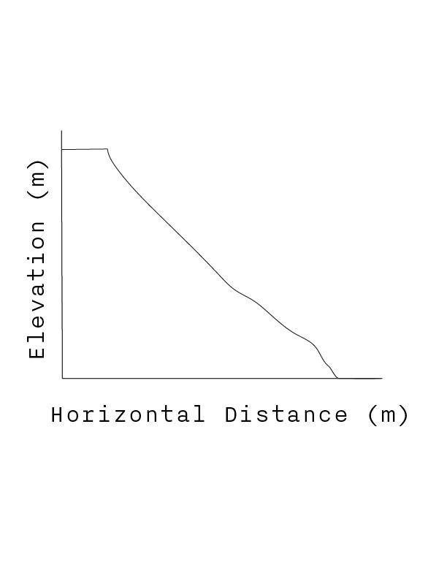
Refer to the profile below (Figure 1)
Figure 1. Schematic profile of a slope

- The profile in Fig. 1 represents a (select one)
- Bluff
- Canyon
- Esker
- Drumlin

- On Fig. 1, label the
a. Toe
b. Face
c. Crest

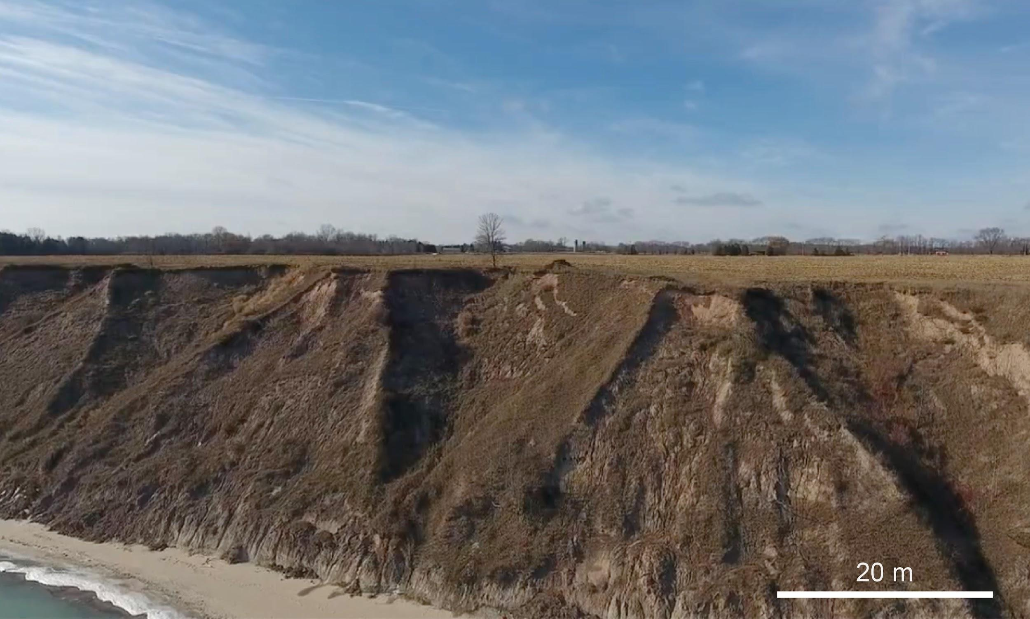
Figure 2. Aerial photo of the Wisconsin coastline along Lake Michigan. Observe the trees and infrastructure on top of the bluff and the lay of the land. For drone footage see https://youtu.be/b32nK4y-tEw

- Draw a sketch of Figure 2. Spend 5 – 10 minutes sketching the scene and labeling at least five (5) features: toe, crest, face, beach, lake, and tree. Annotate or describe your sketch in 1-2 sentences. See an example of a sketch in Figure 3.

  - Your sketch of the coastal bluff:

💡For an example of an annotated sketch, see Figure 3. Use it as a guide to draw your own sketch of the coastal bluff in Wisconsin shown in Figure 2.
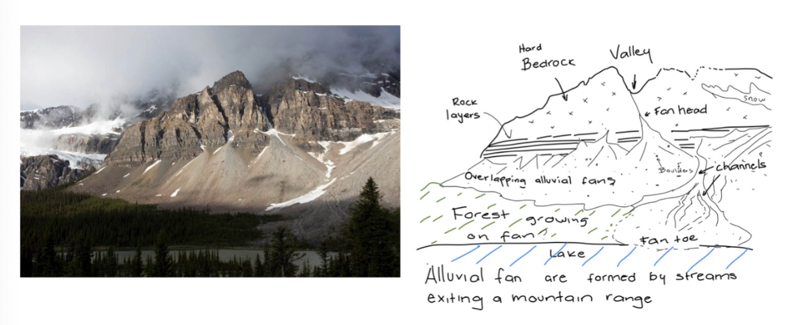
Figure 3. Example sketch: An example geologic sketch from a photograph of Banff National Park, Canada. Note the labels for key features (bedrock, fans, lake) and annotations. The trees and forests provide an idea for the scale. Photo of the left shown for reference, courtesy of Marli Miller (geologypics.com).

  - Now, add arrows and labels to indicate the following:
- areas susceptible to wave erosion,
- areas susceptible to crest recession, and
- areas of erosion by slides.

- Briefly describe three factors that make a bluff stable.

- You’re about to scout the shores of Lake Michigan from the air. Click here to fly to Port Washington, Wisconsin, on Google Earth (43°22’27” N, 87°52’32” W).
  - Fly around the landscape: change your altitude, tilt the view, and switch between 2D and 3D perspectives. Use the Shift and Control keys to navigate like a pro.
  - Investigate the features: examining the numbered spots on the image closely. What do you notice about their shapes, positions, or patterns in the landscape?
  - Mark your findings! Label the six features directly on the image by tracing, outlining, or indicating them. Think of it as annotating a field map.

Your goal is to connect what you see from above to the processes shaping the coast—just like the expert coastal geomorphologist you are.
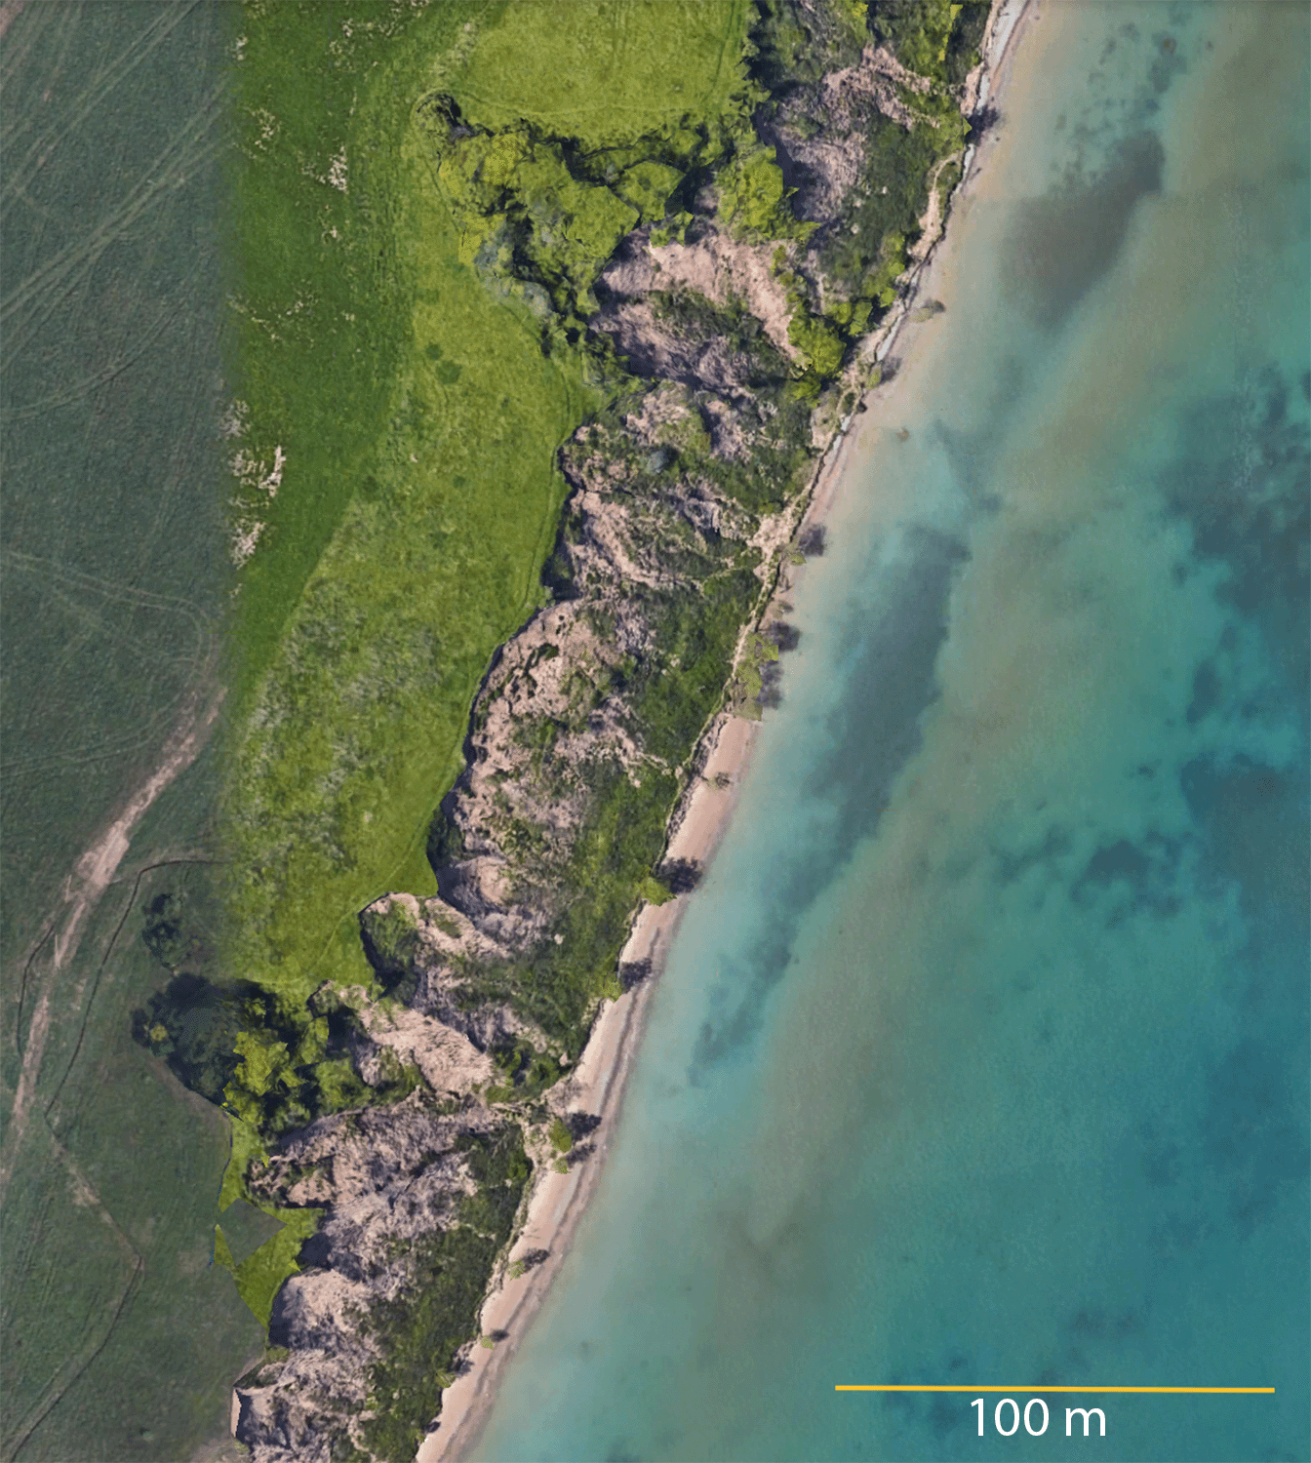
Figure 4. Google Earth overlay of the area of study.
- Crest erosion
- Talus
- Mass wasting processes
- SE-NW trending bluff
- Man-made features
- Lake

B) Changes to the bluff measured with lidar topographic differencing
Now that you have studied the view from above, you decide to study how a bluff profile from the same area changed at different times. Your collaborator created Figure 5 and handed it to you.

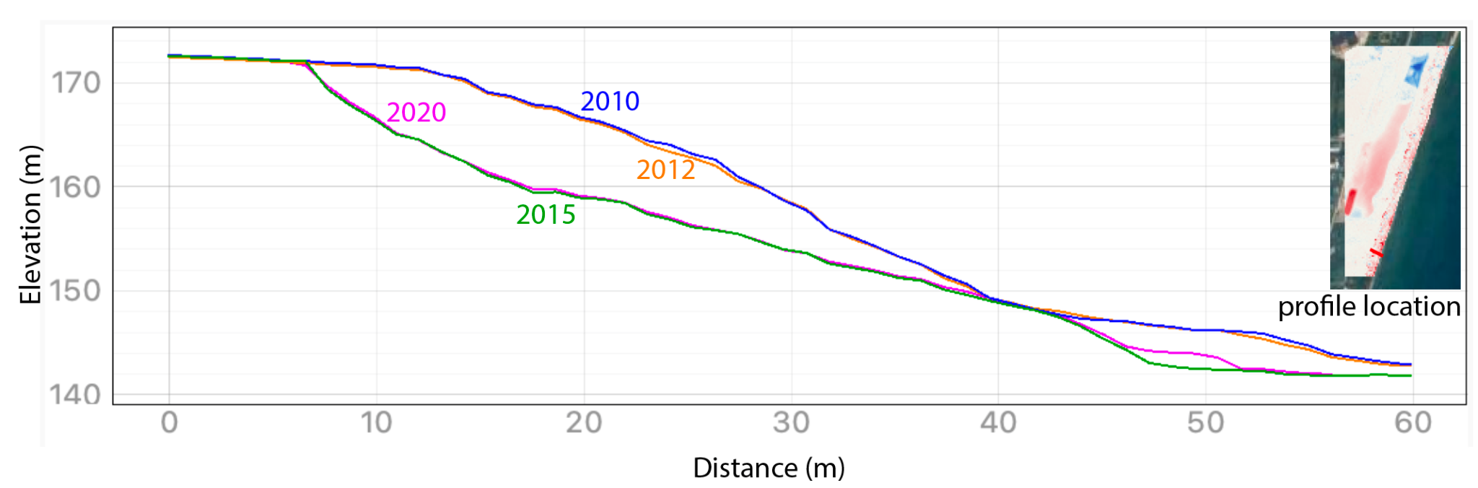
Figure 5. A coastline was measured using multiple lidar topography acquisitions in 2010 (blue), 2012 (orange), 2015 (green), and 2020 (magenta). The elevation of the bluff (meters) is plotted versus distance (meters) perpendicular to the lake coastline.
- Interpret the plot in Figure 5 to answer the following questions:
  - Label the toe, face, and crest of the bluff using the 2010 elevation profile in blue

  - At a x-axis location of 20 m, describe how the landscape changes elevation between 2010, 2012, 2015, and 2020 using meter-scale precision

  - Use the 4 topographic profiles to answer: when did the most significant changes occur along the bluff?

  - What limits the precision of the timing that you can measure to how the bluffs change?

  - How far back did the crest retreat from 2010-2020? When did the most change occur? Mark the change in Figure 5. Describe or sketch how you measured the retreat.

  - In three sentences, describe how the bluff shape changes between 2010-2020? For example, when are different parts of the bluff the steepest? Does the shape of the toe change? What portions of the bluff fail?

  - Based on your results, what would you suggest as the minimum distance from the bluff of any new house or road built along the coast? Assume a constant rate of crest retreat but argue why that may not be the case. Explain

You have just quantified the profile changes! But when did most erosion occur in the landscape? Does it coincide with the most change in the profile? To find this, you recall another way to visualize topographic data: hillshades! Hillshades are 3D-like images of the landscape created from lidar data. Figure 6 shows hillshades for 2010, 2012, 2015, and 2020. The final figure, with red spots, was generated by subtracting the oldest image from the most recent one. Here’s how to read it:

- Red areas = removal of material (erosion or landslides → negative vertical change).
- Blue areas = addition of material (deposition → positive vertical change).

Your task is to interpret these changes and determine when the bluff experienced the most erosion. Think of yourself as piecing together the coastline’s “erosion timeline” to provide evidence for decision-makers.

💡 Tip: Watch the Lake Michigan bluff retreat video using lidar to sharpen your interpretation skills before diving in.

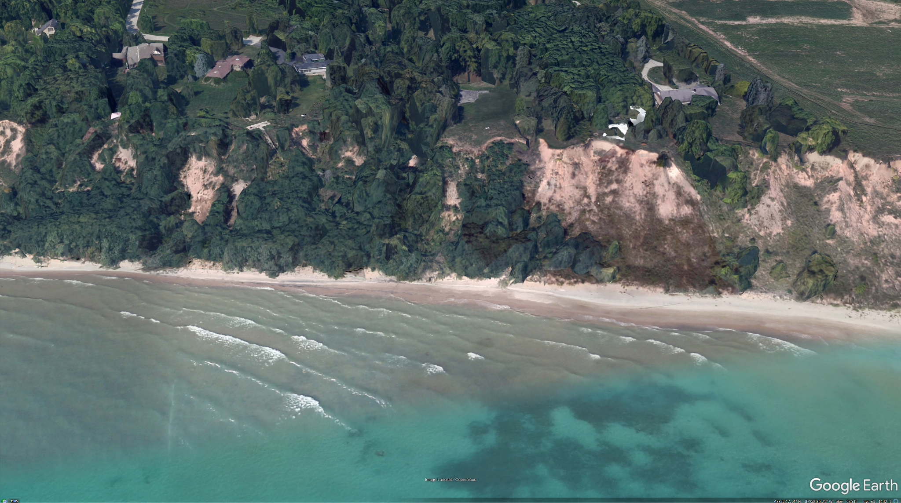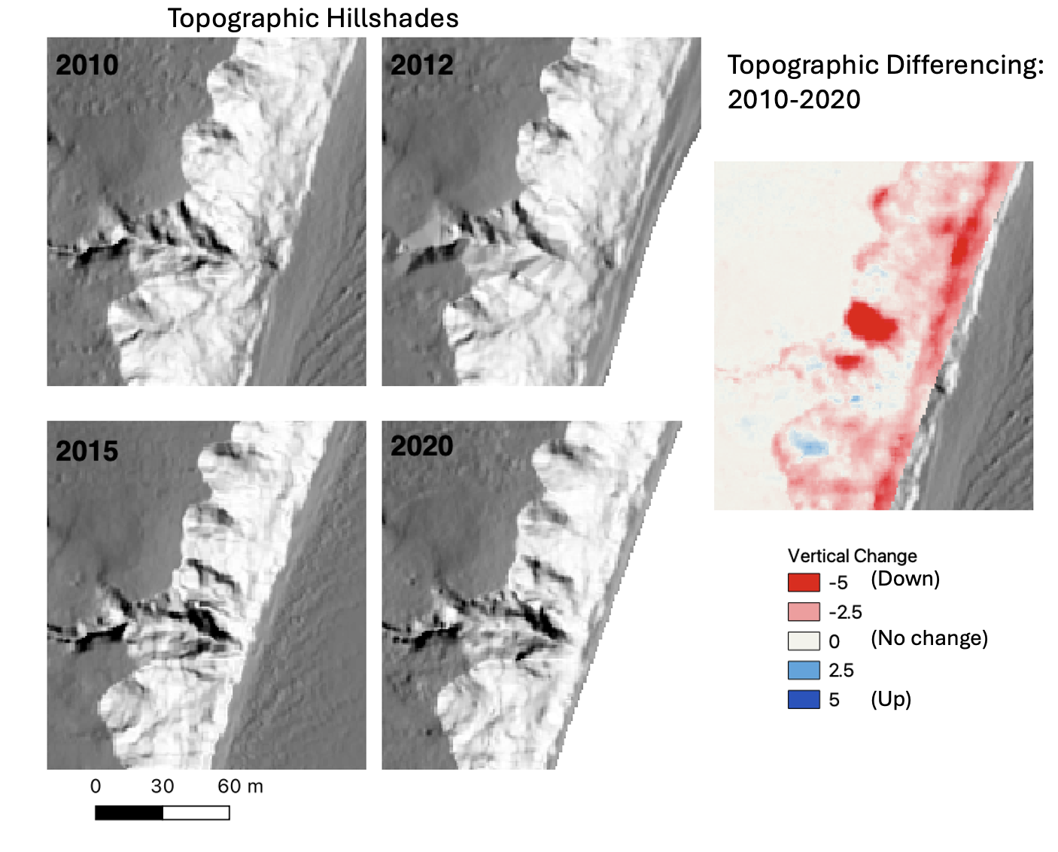
Figure 6. Change along the Michigan coastline. Top: 3D perspective view from Google Earth. Left: topographic hillshades from 2010, 2012, 2015, and 2020. . In these topographic hillshades, the landscape is lit with the sun from the southeast (like we would see in the morning). White and light grey colors represent steep areas with slopes inclined to the east. Dark grey represents flat areas. Right: Vertical change map between 2010- 2020.

- Use Figure 6 to answer the following questions:
  - In the 2010 topographic hillshade, label the crest, face, and toe.

  - In each of the four topographic hillshades, carefully trace the boundary between the crest and the face. Careful tracing is key! This is best done by hand, with a printed lab, or very carefully using the pen tool in PowerPoint.

  - Compare the boundaries in (B) in each of the four hillshades. Where (find and circle) and when did the most significant change in the boundary occur.

  - Describe how the boundary changes. Does the face retreat?

  - Find the area with the boundary change in the topographic differencing map on the right. What happened in the area and immediate downslope. What is the color of the change?

💡 To learn more about how to calculate differencing on OpenTopography by yourself, watch this video: https://youtu.be/qsX6385uAiQ?si=0ol_NZt61f2QwVjf. You can apply this knowledge to any area of interest!

- Observe this time-lapse of a bluff failing: Timelapse bluff failure.mp4. The pictures were taken every 15 minutes. What kind of landslide can you see in the video? Refer to this animated GIF from the USGS: https://www.usgs.gov/media/images/types-landslides

- Topple
- Earthflow
- Translational slide
- Creep

C) Lake water level and bluff erosion
Using different sources of spatial data, you have now learned a great deal about bluff erosion over time. But what causes bluffs to move and change? Of all the possible answers, you decide to investigate how water levels have changed during the 2010-2020 decade.

Go to the Great Lakes water level dashboard maintained by NOAA-Great Lakes Environmental Research Laboratory.

- Select Lake Michigan-Huron
- Select start year: 2010, End year: 2020

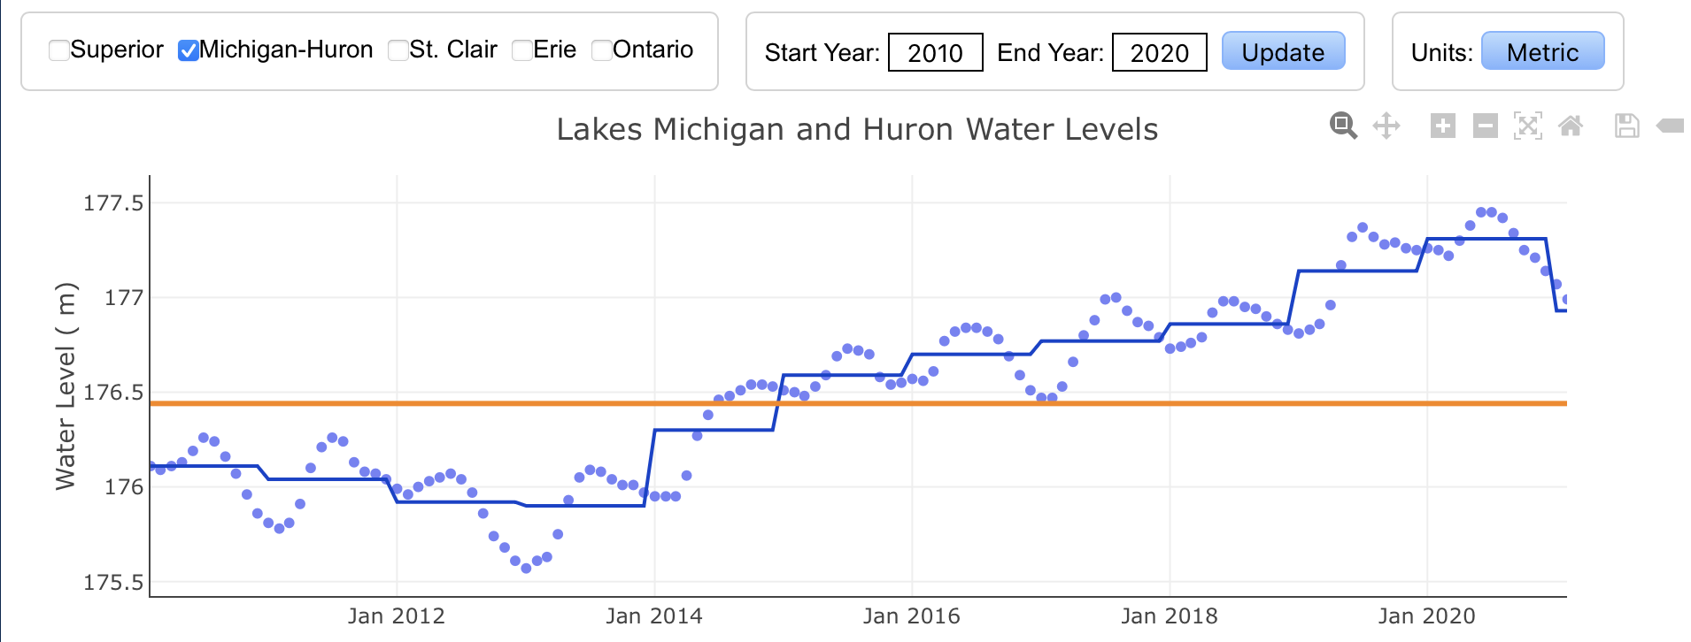
Figure 7. The Great Lakes water dashboard, showing the selected options. This figure can be used instead of the website.

- Interpret Figure 7 to answer the following questions:
  - From the above graph, when was the lowest peak of the water level?

  - When was the highest level?

  - What was the water level at each of those times?

  - What year did the water level change from below average level to above average level?

- Make and justify a prediction about when the erosion would be the highest at the bluff toe based on the lake water levels. Make and justify a second prediction about when the erosion would be the highest at the bluff face based on the lake water levels.

- In one to two sentences, describe how you would evaluate your prediction based on the topographic differencing results in the Figures above.

In science, one of the most exciting parts is making predictions and then testing them against real data. As a coastal geomorphologist, you are a detective–making your best guess about what happened and then gathering further evidence to see if you were right. When predictions don’t match the data, that’s not a failure–it’s discovery! Each “wrong” prediction is an important opportunity to improve our understanding of how Earth works, and it helps us make better predictions in the future. It is acceptable when predictions are not correct and can be improved, as long as you take the opportunity to learn more about the active geologic process, the powerful forces constantly reshaping our planet.

- Was your prediction in #11 correct? If not, why not? Describe in one to two sentences, what was correct or incorrect about your prediction.

- Given that the waves attack the toe of the bluff, explain why the bluff fails at the top and the crest retreats?

- Review the differencing and water level figures and list two observations about the erosion and water level that you could use to inform a future prediction.

- In this lab you used satellite images from Google Earth (Q6), topographic data (topographic hillshade and differencing, Q8), a time lapse video (Q9), and a data dashboard of the Great Lakes (Part 3). In a paragraph (250 words minimum) described how you used each of these. In addition, reflect on how using all of them collectively helped you study and understand the processes involved in coastal bluff erosion.

- If a homeowner asks you about the risks of bluff erosion, what would you explain to them in three sentences? How does data help guide your interpretations?

- You are a participant in a town hall community responding to the recent bluff collapse and someone says that because the bluff collapse has already happened, there will be no more bluff collapses for 100 years. What is your 1-minute response?

REFERENCES AND RESOURCES
Krueger, R., Zoet, L. K., & Rawling III, J. E. (2020). Coastal bluff evolution in response to a rapid rise in surface water level. Journal of Geophysical Research: Earth Surface, 125(10), e2019JF005428.https://agupubs.onlinelibrary.wiley.com/doi/full/10.1029/2019JF005428
Internet Geography. (n.d.). Field sketches in Geography. https://www.internetgeography.net/field-sketches-in-geography/
National Oceanic and Atmospheric Administration. (n.d.). Office for Coastal Management. U.S. Department of Commerce. https://coast.noaa.gov
National Oceanic and Atmospheric Administration. (2010). 2020 USACE NCMP Topobathy Lidar: Lake Michigan (IL, IN, MI, WI). Distributed by OpenTopography. https://portal.opentopography.org/noaaDataset?noaaID=5042, last accessed 2025-01-01.
National Oceanic and Atmospheric Administration. (2012). 2012 USACE NCMP Topobathy Lidar: Lake Michigan (IL,IN,MI,WI). Distributed by OpenTopography. https://portal.opentopography.org/noaaDataset?noaaID=10170, last accessed 2025-01-01.
National Oceanic and Atmospheric Administration. (2020). FEMA Lidar: Ozaukee County (WI). Distributed by OpenTopography. https://portal.opentopography.org/noaaDataset?noaaID=9232, last accessed 2025-01-01.
University of Wisconsin Sea Grant Institute. (n.d.). Coastal processes and erosion. Board of Regents of the University of Wisconsin System. https://www.seagrant.wisc.edu
U.S. Geological Survey. (2019). USGS LPC WI SEWRPC 2017 LAS 2019. Distributed by OpenTopography. https://portal.opentopography.org/usgsDataset?dsid=USGS_LPC_WI_SEWRPC_2017_LAS_2019, last accessed 2025-01-01.
U.S. Geological Survey. (n.d.). USGS coastal change hazards. U.S. Department of the Interior. https://www.usgs.gov/coastal-change-hazards
Wisconsin Coastal Management Program. (n.d.). Wisconsin coastal management program. Wisconsin Department of Administration. https://coastal.wisconsin.gov
Wisconsin Department of Natural Resources. (n.d.). Coastal management and shoreland zoning. State of Wisconsin. https://dnr.wisconsin.gov
Wisconsin Geological and Natural History Survey. (n.d.). Geologic hazards and coastal processes. University of Wisconsin–Madison Division of Extension. https://wgnhs.wisc.edu
Zoet, L., Rawling, J., Roland, C., Krueger, R., Volpano, C. A., & Theuerkauf, E. (2021). An Overview of Coastal Bluff Stability Along the Great Lakes. In Geological Society of America Abstracts (Vol. 53, p. 361505). https://gsa.confex.com/gsa/2021NC/webprogram/Paper361505.html

Acknowledgements: OpenTopography is supported by the National Science Foundation under Award Numbers 2410799, 2410800 & 2410801
Author contributions
Carolina Michel and Chelsea Scott developed the activity. Kate Flick and Sally Stevens, at the College of the Menominee Nation, used this lab during Spring 2025 in the College of the Menominee Nation (CMN) Geomorphology class (Geo 202) and adapted it to Canvas. We thank them for their feedback and contributions. Lucas Zoet provided the foundations for this lab and the CMN Geomorphology class. Bett Pratt Sitaula provided valuable feedback to make this activity better.

Government and regulatory agencies and scientific/ research sources provide reports, maps and zoning guides. Potential resources to learn more are compiled under references and resources.

